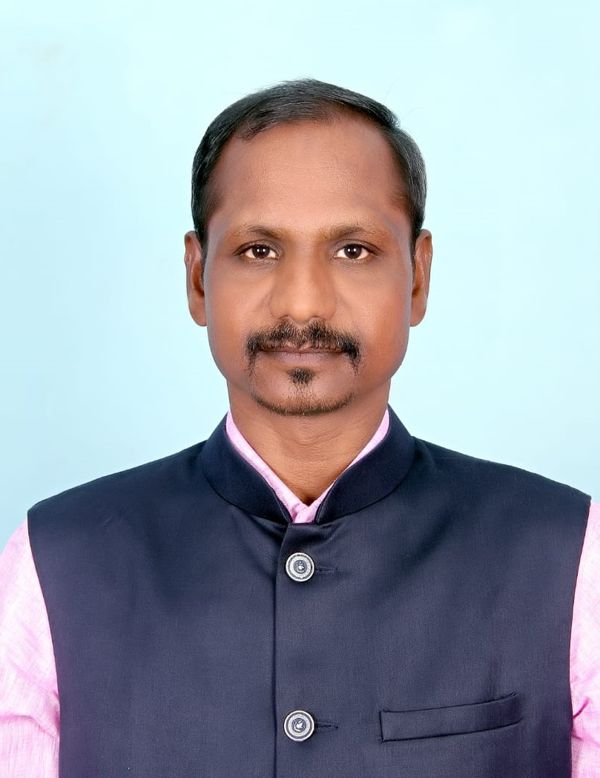
Prof. K. Chinnappan,
Syndicate Member,
Dean, Faculty of Developing Tamil,
Head,Dept. of Education and Management
Tamil University,Thanjavur –10
Tamil Nadu, India
Email: ku.chinnappan@gmail.com, Mobile: 9443181034
.

Date of Birth - 08.05.1969

Academic Qualification - M.A., M.Phil., Ph.D., (Tamil Lit.)
M.Ed., M.Phil., Ph.D.,(Edn), M.A.,(Soci.),M.A., Ph.D.,(JMC).,
Professional Experience - 22 Years : UGLevel : 22 Years
PG Level : 14 Years

Teaching - Professor, Dept. of Education, Tamil University, Thanjavur
(02.07.2013 to till date).

- Associate Prof., Dept. of Education, Tamil University, Thanjavur
(02.07.2010 to 01.07.2013)

- Reader, Dept. of Education, Tamil University, Thanjavur
    - to 01.07.2010)
- Asst. Prof., Dept. of Tamil, Pope John Paul II College of Education, Puducherry, (16.06.1999 to 30.06.2007)

Research Supervisor - Ph.D’s., Awarded : 32 Ongoing : 10
Research Project - Short Term Project Completed : 2
Publication - Books – Authored : 18 Edited : 1
Co-Edited : 1

Research Papers - Published : 40 Co-Authored : 19
Presented : 16

Area of Specialization - • Teaching of Tamil Education
• Education and Media
• Life Skills Education

Position Held - Registrar (i/c)
Tamil University, (29.07.2019-30.06.2021)
Thanjavur
- Controller of Examinations (i/c),
(02.01.2019 – 28.07.2019)

- Dean, Faculty of Developing Tamil,
(01.07.2019 – till Date)
- Head, Dept. of Education,
(09.11.2011 to till date)
- Co-ordinator, Career and Counselling Cell
(30.09.2013 to till date)
- Co-ordinator, Placement Cell
(30.07.2018 to till date)
- Centre Co-ordinator, B.Ed., (DDE)
(18.11.2008 to 18.11.2013)
- Co-ordinator, Research Colloquim
(02.12.2003 to 02.12.2014)
- Head, Dept. of Tamil. Pope John Paul II College of Education
Puducherry (16.06.1999 to 30.06.2007)

Career Development
Programmes Participated - Orientation Course : 1
Refresher Courses : 2
Seminars : 15
Workshops : 12
International Seminar : 2
Organised - Conference : 4
Seminars : 5
Workshops : 11

Participation in Mass Media - All India Radio Programme : 6
Television Programmes (DD) : 10

Motivational Speeches - Special Address es : 133

Award/ Honours Received
International Level • The Best Educationist Award, Kuwait
(March 29, 2019)

National Level • Dr.B.R.Ambedkar National Award, CBCI, New Delhi
(May 23, 2016)
• Higher Education Award, St.Joseph’s College, Trichy
(Dec 15, 2012)

State Level • The Best Researcher in Theatre Award, Aarakkonam,Vellore (Dt)
(Sep 7, 2015)

• Self Confidence Award, Siruvachiyur, Perambalur (Dt),
(Oct 5, 2012)
Member of Academic and
Professional Bodies
• Doctoral Committee, Dept. of Education,
Periyar Maniammai University, Thanjavur.

• Board of Studies, Dept. of Education,
Alagappa University, Karaikudi.

• Editorial Board, Bon Secours Journal on Educational
Research, (BONJER) Thanjavur.
Residence Address - A2, Mullai Illam,
Tamil University Quarters,
Trichy Road, Thanjavur-613 010.

